ENERGY AND THE FOUR WATCHTOWER ARCHANGELS WORKSHOP

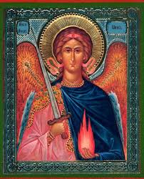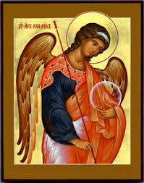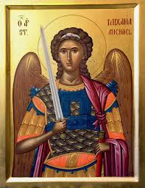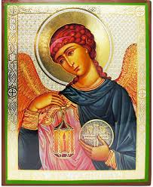
-Learn about what energy is and the electromagenetic spectrum of light
-Get a greater understanding of your energetic aura
-Gain information about the four watchtower angels: Micheal, Raphael, Gabriel and Uriel
-Receive a one card angel card reading
-Experience a guided meditation and see what message the archangels have for you!

COME AND MEET THE SPIRITUAL SCIENTIST IN THIS SPECIAL WORKSHOP
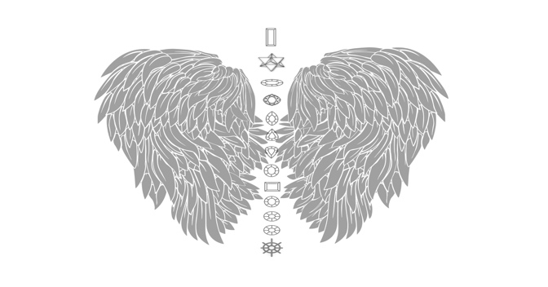
DATE : 6TH APRIL 2019

TIME: 1.15PM – 245PM

LOCATION: Buddha on a BIcycle
27 Endell Street WC2H 9BA

EXCHANGE: £15

TO BOOK YOUR PLACE- EMAIL: angelicmagic@outlook.com
www.mariaafentakis.com

